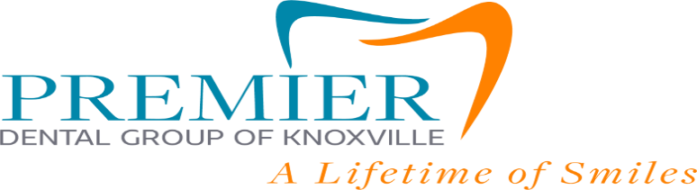
303 South Concord Street, Suite 323 Knoxville TN 37214

COVID -19 Pandemic, Dental Treatment Consent Form
I, _________________________________________ knowingly and willingly consent to have dental treatment completed during the COVID-19 pandemic.
I understand the COVID-19 virus has a long incubation period during which carriers of the virus may not show symptoms but may still be contagious.
I understand that what is currently known about the COVID-19, is that the spread is thought to occur mostly from person-to-person via respiratory droplets when in close contact.
I understand that with the unknowns of the virus, the procedures that have been performed in the practice along with the number of patients that have been here, that I have increased risk of contracting the virus by receiving treatment in the practice or by being in the practice.
I acknowledge that my forehead will be scanned with a thermal thermometer upon arrival.
I understand that the symptoms listed below represent COVID-19:
- Fever
- Shortness of Breath / Difficulty breathing
- Dry Cough
- Temperature of 100 degrees or above
- Persistent pressure of pain in the chest
- Sore Throat / Runny nose

I confirm that I do not display or currently have any of the above symptoms that represent the COVID-19: ____________(initial)
I confirm that I have not traveled outside the United States within the past 14 days to any of the countries or regions with widespread ongoing transmission. _____________(initial)

Patient Name: _________________________________________

Patient / Guardian Signature: ____________________________________________

Date: _________________

